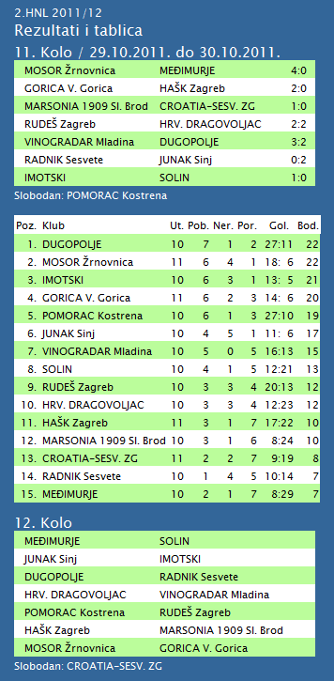
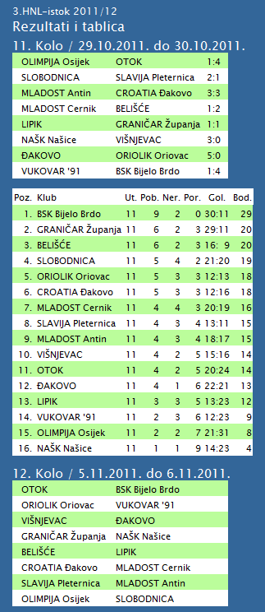
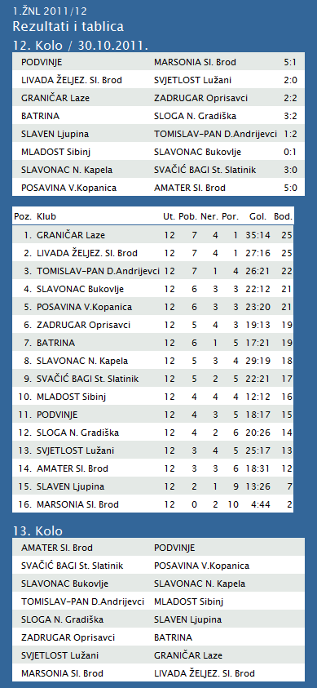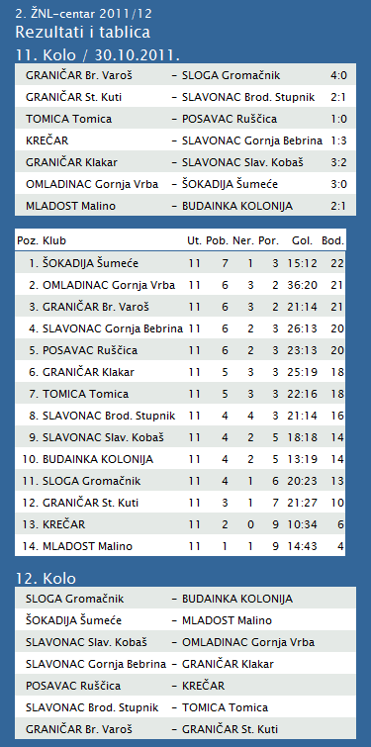
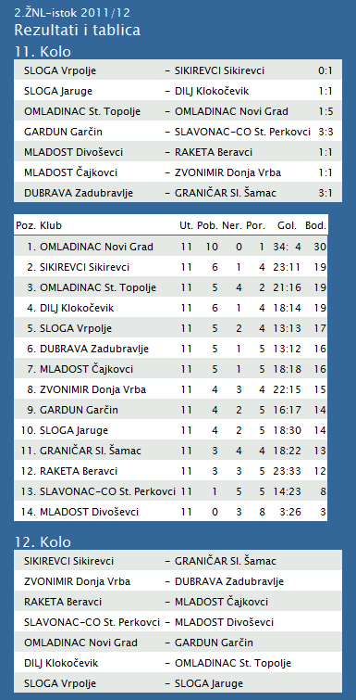
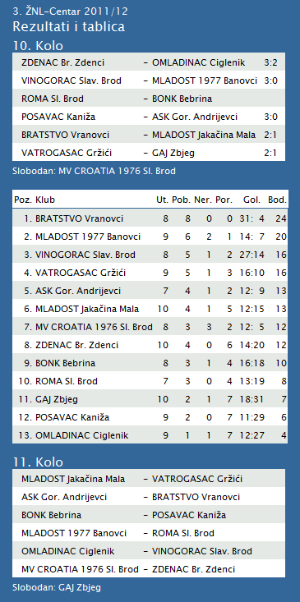

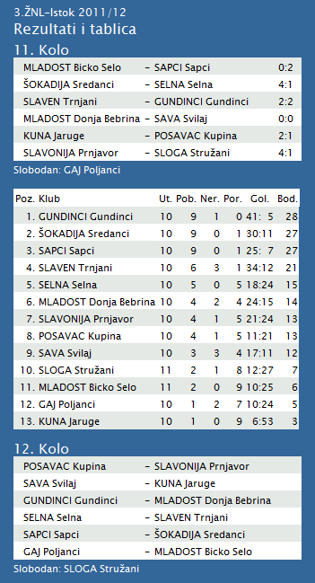
1. HRL muški

Ukupni rezultati:
 |  | U | P | N | P | DP | BOD.
1. | VIDOVEC-BIOS | 8 | 7 | 0 | 1 | 248:194 | 14
2. | DUGO SELO | 8 | 6 | 0 | 2 | 268:244 | 12
3. | MEDVEŠČAK NFD | 8 | 6 | 0 | 2 | 234:212 | 12
4. | OSIJEK | 8 | 5 | 0 | 3 | 247:232 | 10
5. | MOSLAVINA | 8 | 5 | 0 | 3 | 228:213 | 10
6. | MLADI RUDAR | 8 | 4 | 1 | 3 | 214:209 | 9
7. | SENJ-WALLENBORN | 8 | 4 | 1 | 3 | 228:231 | 9
8. | UMAG | 8 | 3 | 2 | 3 | 234:227 | 8
9. | ĐAKOVO | 8 | 4 | 0 | 4 | 216:221 | 8
10. | ŽUPANJA | 8 | 4 | 0 | 4 | 211:222 | 8
11. | BROD | 8 | 2 | 0 | 6 | 206:235 | 4
12. | CRIKVENICA | 8 | 2 | 0 | 6 | 204:235 | 4
13. | IVANČICA IVANEC | 8 | 1 | 0 | 7 | 230:255 | 2
14. | BIOGRAD | 8 | 1 | 0 | 7 | 208:246 | 2

2. HRL sjever žene

Ukupni rezultati:
 |  | U | P | N | P | DP | BOD.
1. | OSIJEK PSC | 6 | 6 | 0 | 0 | 196:107 | 12
2. | PETRIJEVCI | 6 | 6 | 0 | 0 | 219:180 | 12
3. | BJELOVAR | 6 | 4 | 1 | 1 | 171:166 | 9
4. | ZRINSKI | 6 | 3 | 1 | 2 | 173:164 | 7
5. | BROD-GYMNASIUM | 6 | 3 | 1 | 2 | 153:144 | 7
6. | ĐURĐEVAC | 6 | 3 | 0 | 3 | 175:176 | 6
7. | PODRAVKA-LINO | 6 | 2 | 1 | 3 | 180:176 | 5
8. | PITOMAČA | 6 | 2 | 1 | 3 | 168:189 | 5
9. | DARDA | 6 | 2 | 0 | 4 | 169:185 | 4
10. | CERNA | 6 | 2 | 0 | 4 | 149:172 | 4
11. | IVANEC | 6 | 0 | 1 | 5 | 161:211 | 1
12. | VUKOVAR | 6 | 0 | 0 | 6 | 132:176 | 0

TABLICA A1 MUŠKA LIGA
# |  | Klub | W | L | Bod | Omjer |  |  | Razlika
 | 1 | KK Križevci (-16) | 3 | 1 | 7 | 352 | : | 351 | 1
 | 2 | KK Split (-16) | 3 | 1 | 7 | 331 | : | 308 | 23
 | 3 | KK Jolly JBS (-16) | 3 | 1 | 7 | 318 | : | 289 | 29
 | 4 | KK Zadar (-16) | 3 | 1 | 7 | 297 | : | 252 | 45
 | 5 | KK Kvarner 2010 (-16) | 3 | 1 | 7 | 321 | : | 317 | 4
 | 6 | KK Sonik-Puntamika (-16) | 1 | 3 | 5 | 295 | : | 286 | 9
 | 7 | KK Zabok (-17) | 2 | 1 | 5 | 248 | : | 241 | 7
 | 8 | KK Alkar (-17) | 1 | 2 | 4 | 211 | : | 223 | -12
 | 9 | KK Brod Svjetlost (-17) | 1 | 2 | 4 | 204 | : | 232 | -28
 | 10 | KK Dubrovnik (-16) | 0 | 4 | 4 | 317 | : | 363 | -46
 | 11 | KK Vrijednosnice OS Darda (-17) | 0 | 3 | 3 | 212 | : | 244 | -32

